Saurav Shrestha

[company name]

Admin Interface Testing

Organocity

# Table of Contents:

1. Login
2. Report
3. Accounts
4. Product
5. Collection Slot
6. Sign out

# Admin Interface Testing

1. Login
   1. With empty fields

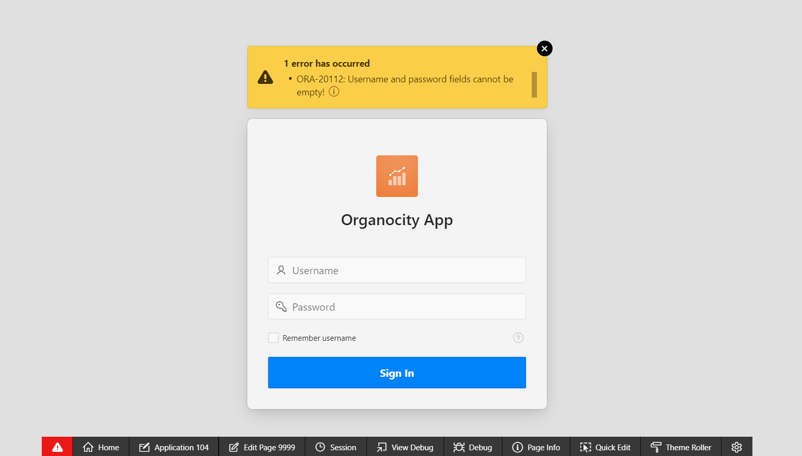

“Error Message”

* 1. With invalid details

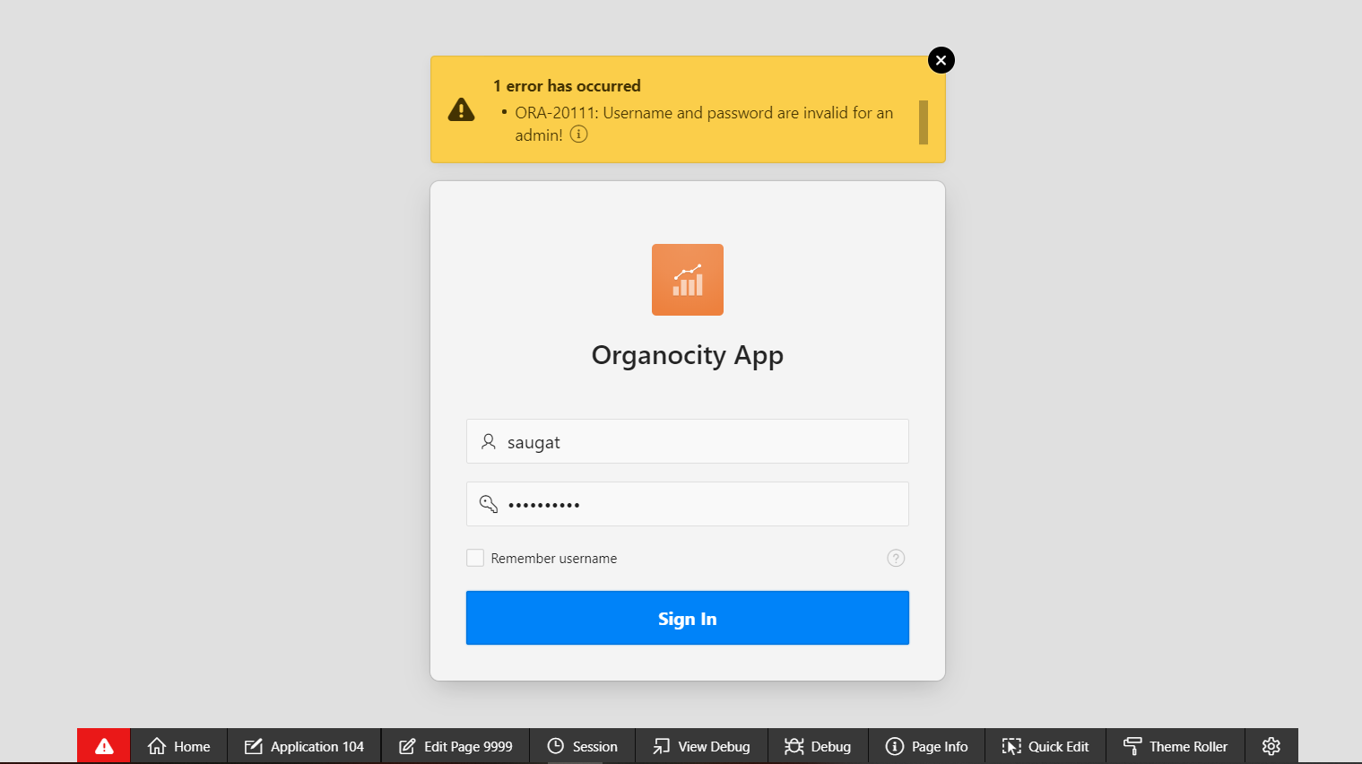

“Error message”

* 1. With appropriate details

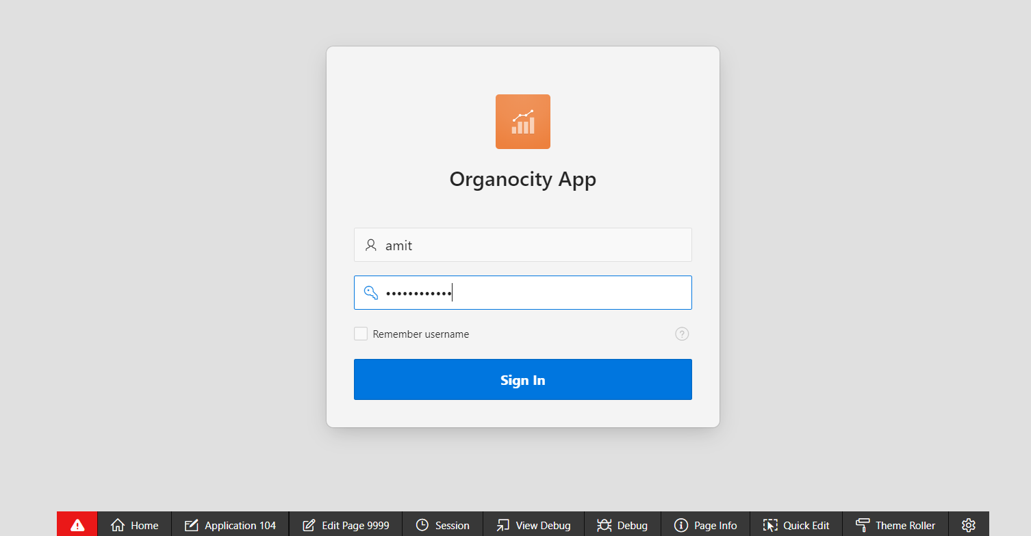

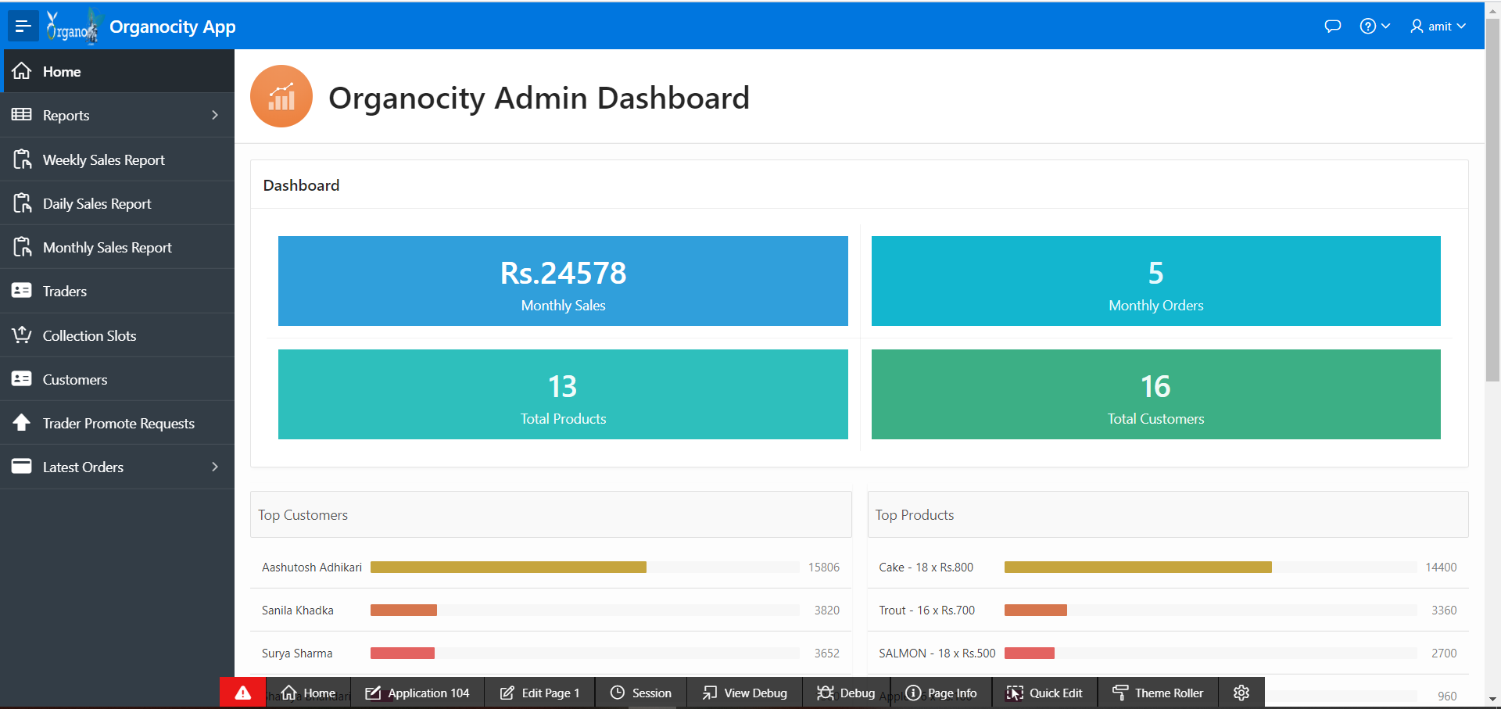

“Logs in and redirected to admin dashboard”

1. Report
   1. Able to view combined daily report

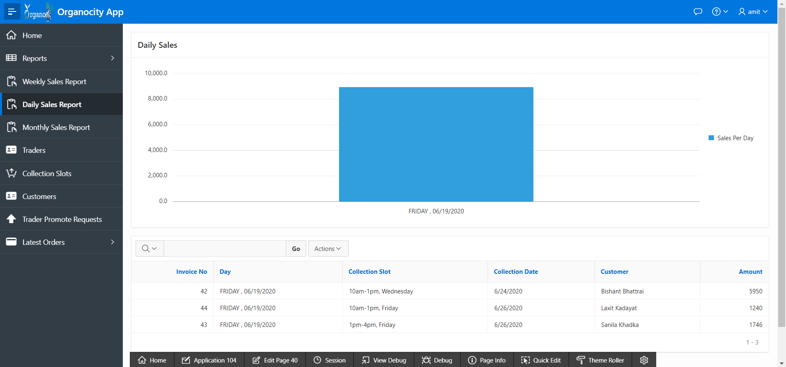

“Report displayed”

* 1. Able to view combined weekly report

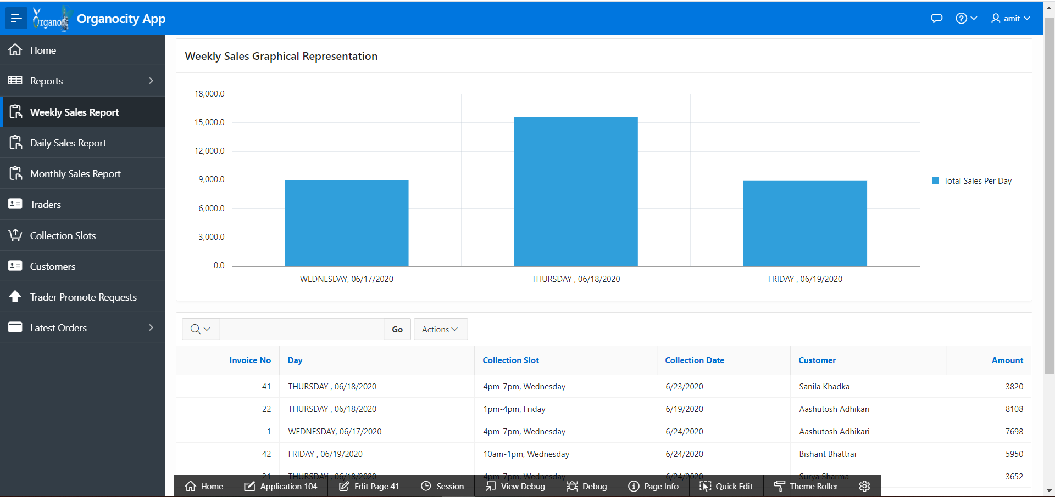

“Report displayed”

* 1. Able to display combined monthly report

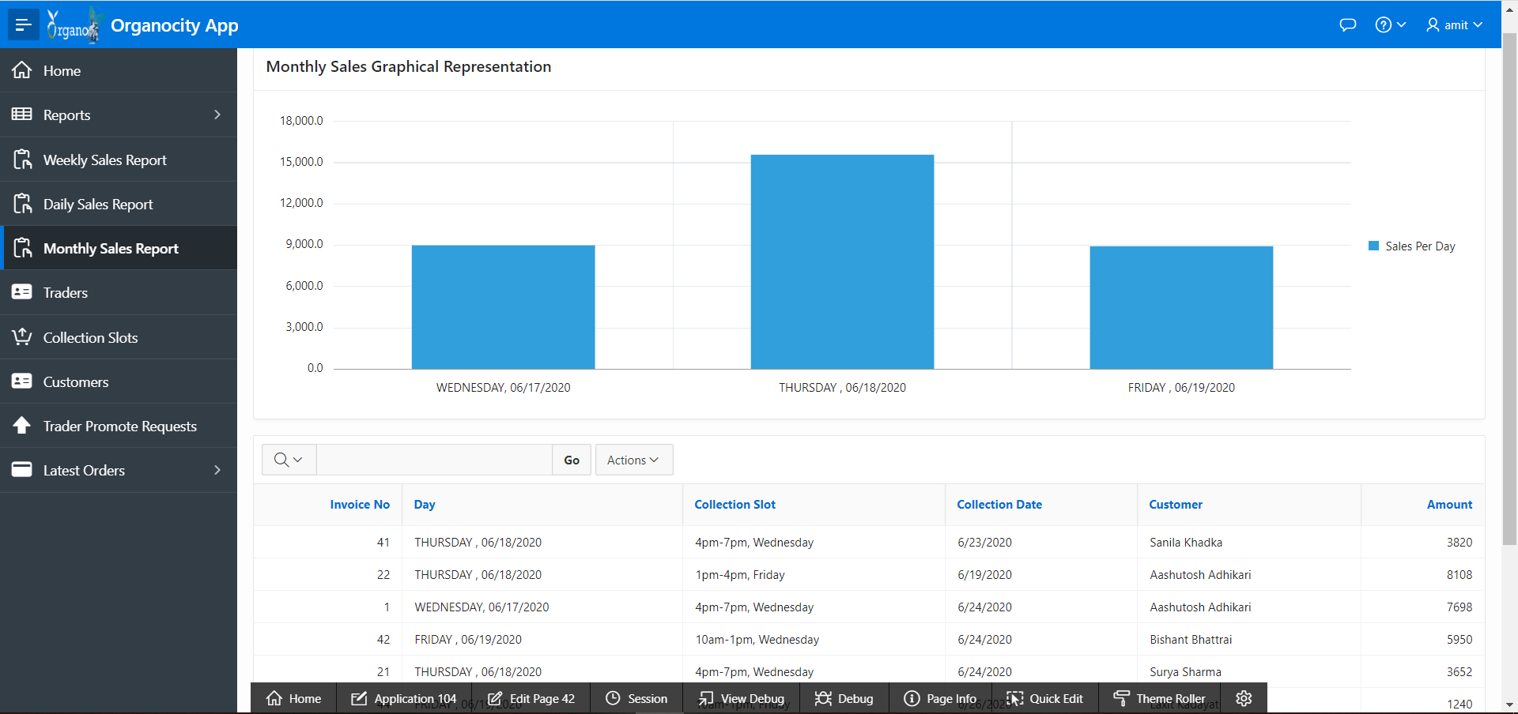

“Report displayed”

1. Accounts
   1. Admin can view trader accounts

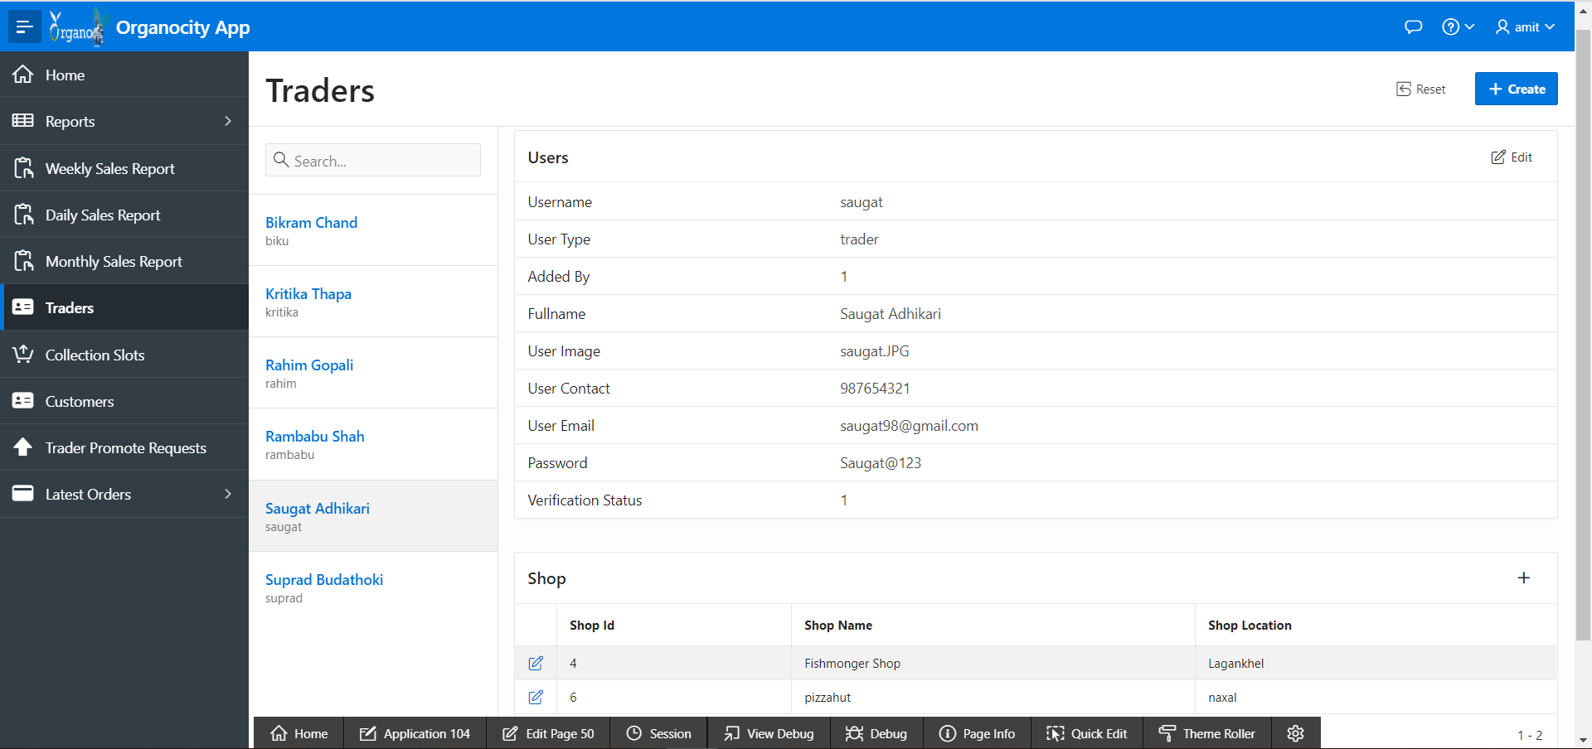

“Account shown”

* 1. Admin can view customer accounts

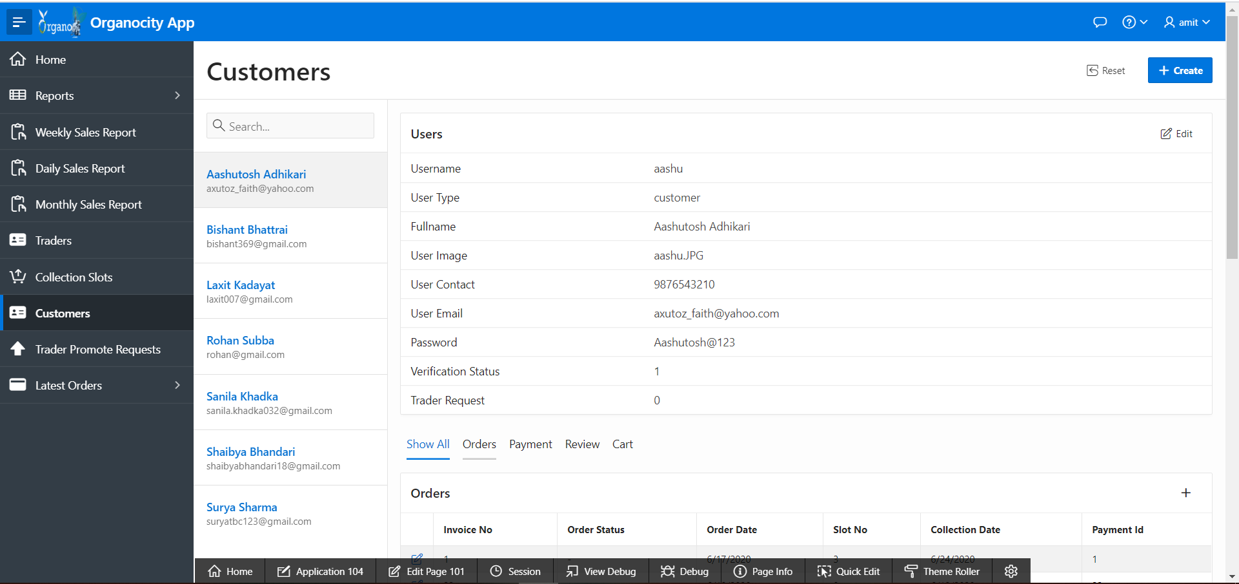

“Account shown”

* 1. Admin is able to edit trader accounts

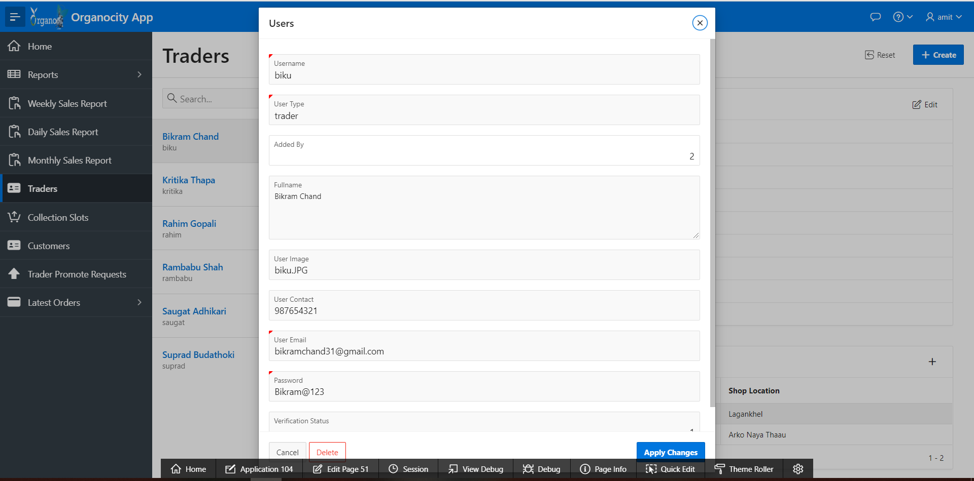

“Account edited”

* 1. Admin is able to edit customer accounts

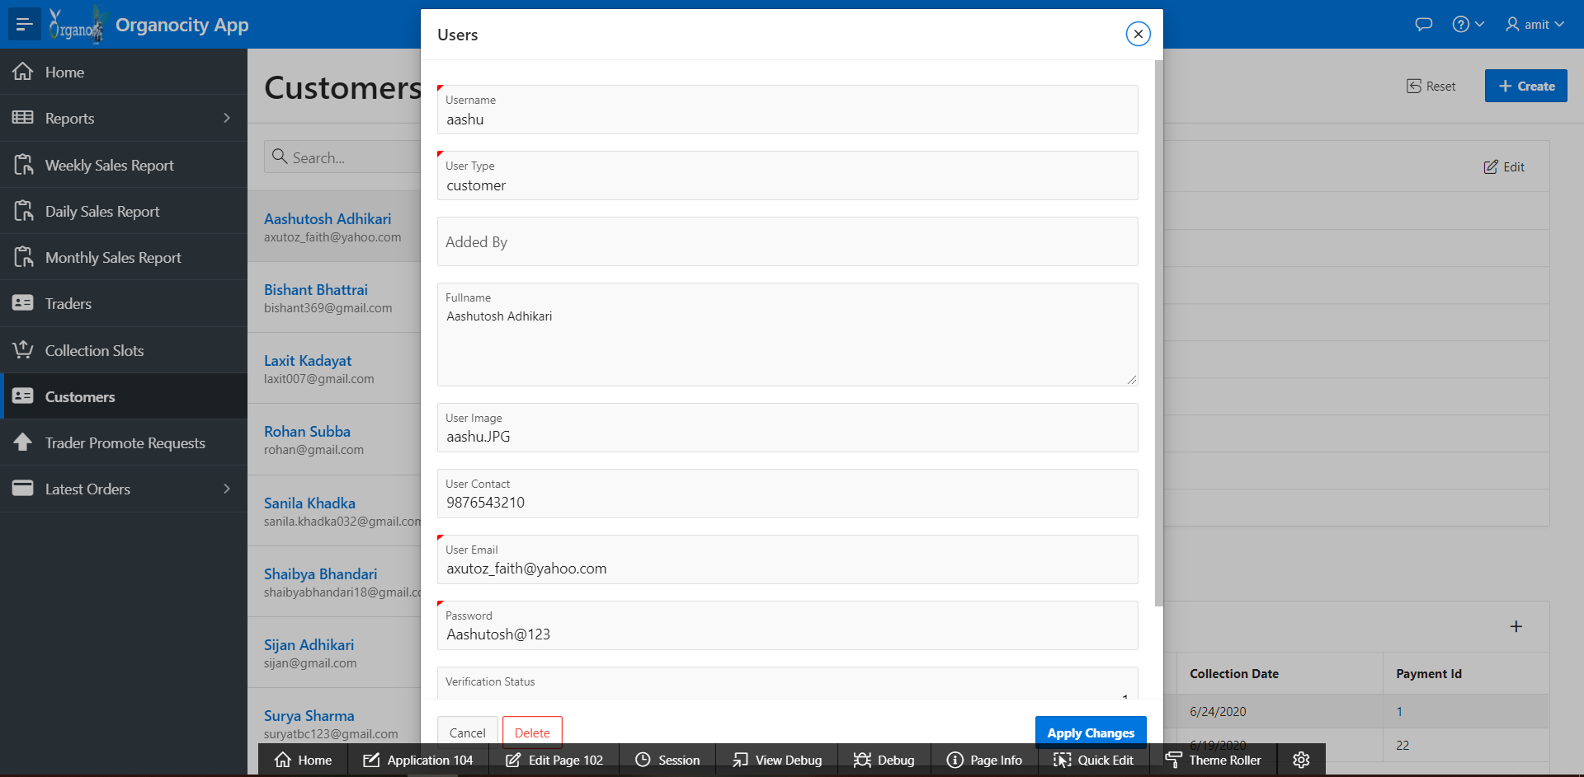

“Account edited”

1. Products
   1. Admin can view every product

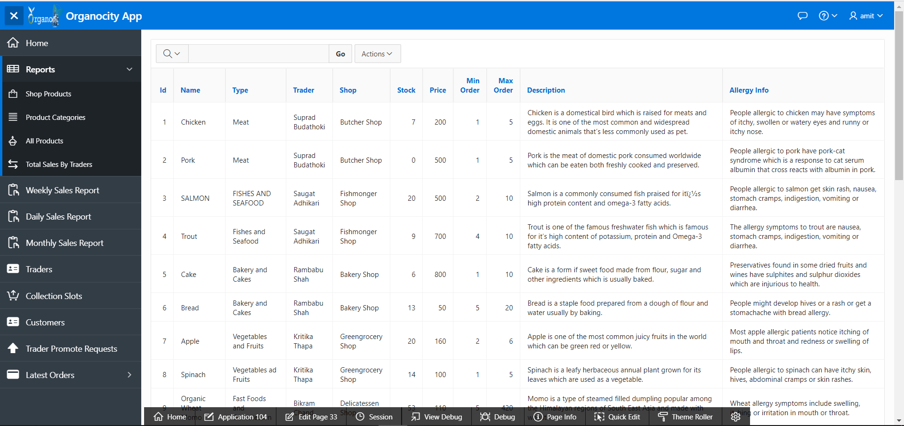

“Product displayed”

1. Collection Slot
   1. Admin can view the number of orders placed on each slots.

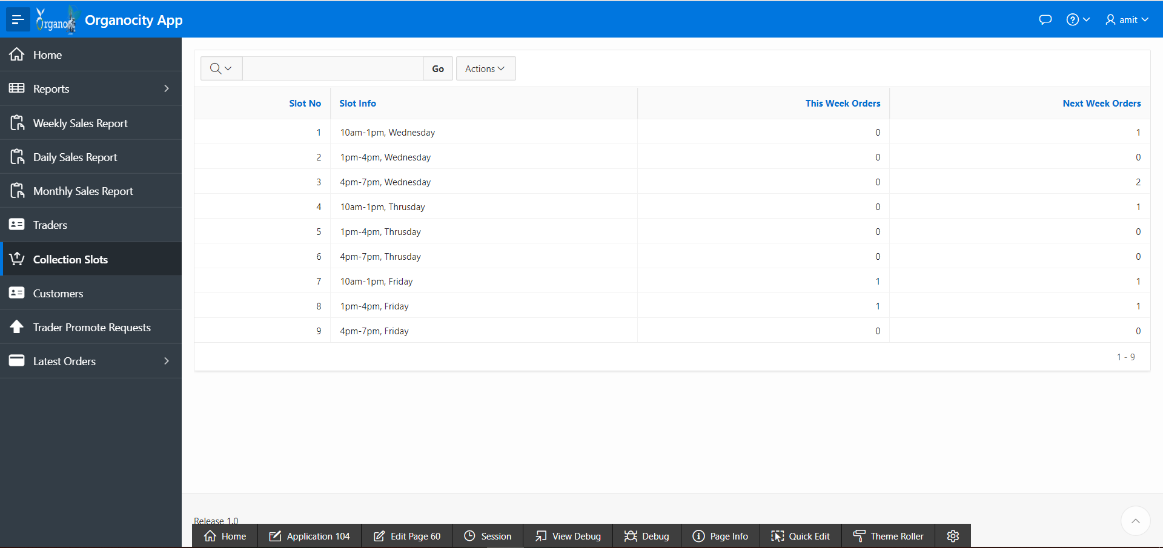

“Slots report displayed”

1. Sign out
   1. Admin signs out

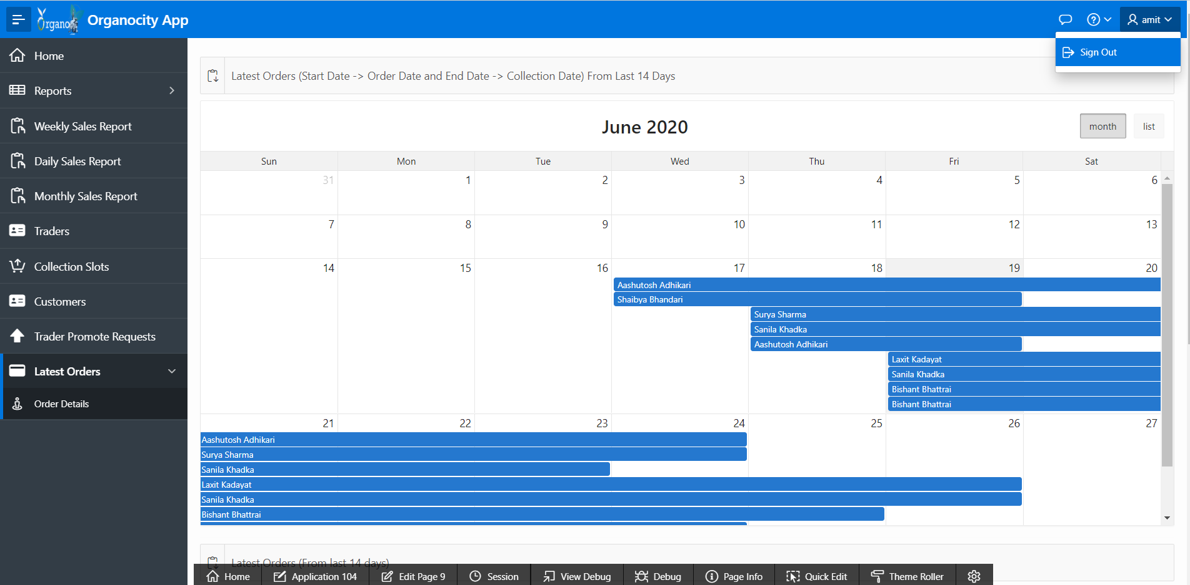

“Admin signs out”